14주차 과제

[과제번호9]_4조_20115122,20135151

1번

f = open('homework.txt','w')

data = "산토끼 토끼야;어디를 가느냐;깡총 깡총 뛰어서;어디를 가느냐"

f.write(data)

f.close()

f = open('homework.txt', 'r')

data = f.read()

result = data.split(';')

print('all line = ', result)

f.close()

print('1 = ', result[0])

print('2 = ', result[1])

print('3 = ', result[2])

print('4 = ', result[3])

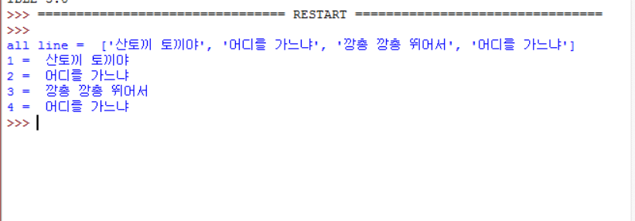

2번

class Car():

def __init__(self):

print("Car : ready")

self._speed = 0

def start(self):

print("Car : start")

self._speed = 20

def accelerate(self):

self._speed += 30

def get_speed(self):

return self._speed

def stop(self):

print("Car : stop")

self._speed = 0

return self._speed

def test():

my_car = Car()

my_car.start()

print("Velocity: ", my_car.get_speed())

my_car.accelerate()

print("Velocity: ", my_car.get_speed())

my_car.stop()

print("Velocity: ", my_car.get_speed())

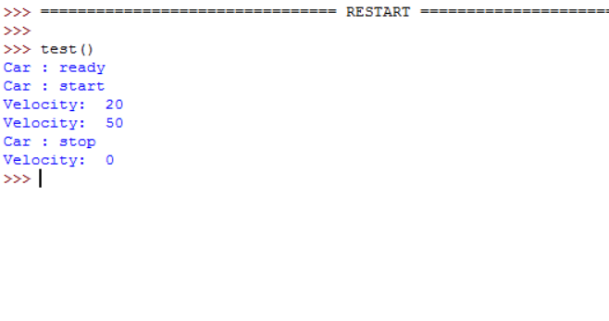

3번

class Radio():

def on(self):

print("Radio On")

def off(self):

print("Radio OFF")

class Car():

def __init__(self):

print("===Car===")

print("===radio===")

self.radio = Radio()

def start(self):

print("Car : start")

def turn_on_radio(self):

self.radio.on()

def turn_off_radio(self):

self.radio.off()

def accelerate(self):

print("Car : start")

def stop(self):

print("Car : stop")

def test():

my_car = Car()

my_car.start()

my_car.turn_on_radio()

my_car.accelerate()

my_car.turn_off_radio()

my_car.stop()

test()

